🐧 PART 1 — Create Linux EC2 Instance

Step 1: Go to EC2
- Login to AWS Console
- Search EC2
- Click Launch Instance

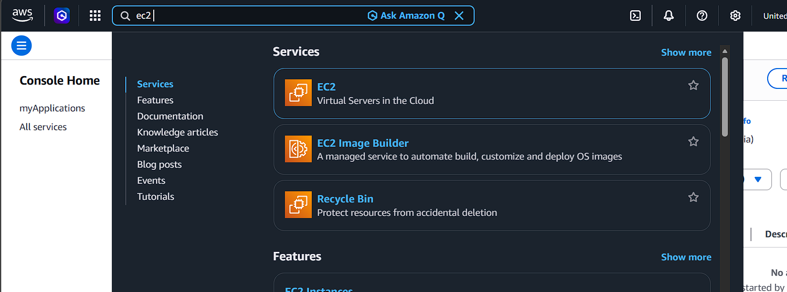

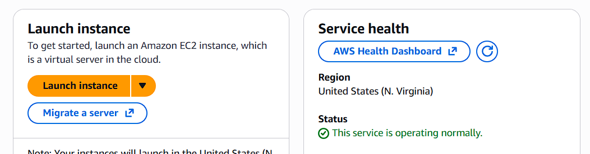

Step 2: Name the Instance
Name:
studentname-linux-vm
Example:
saravana-linux-vm

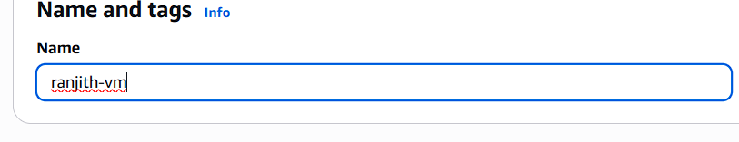

Step 3: Choose AMI
Select:
- Amazon Linux 2023 (Free tier eligible)

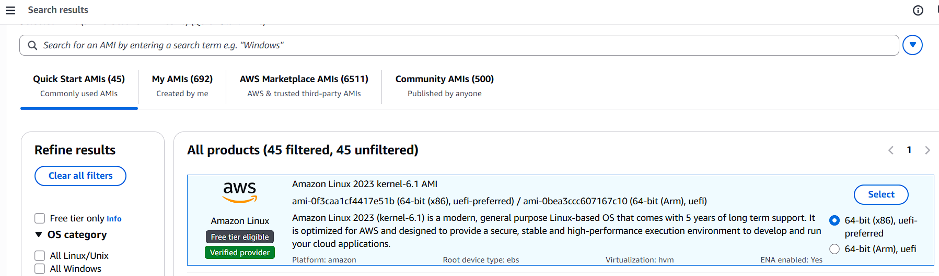

Step 4: Choose Instance Type
Select:
t2.micro
(Free tier eligible)

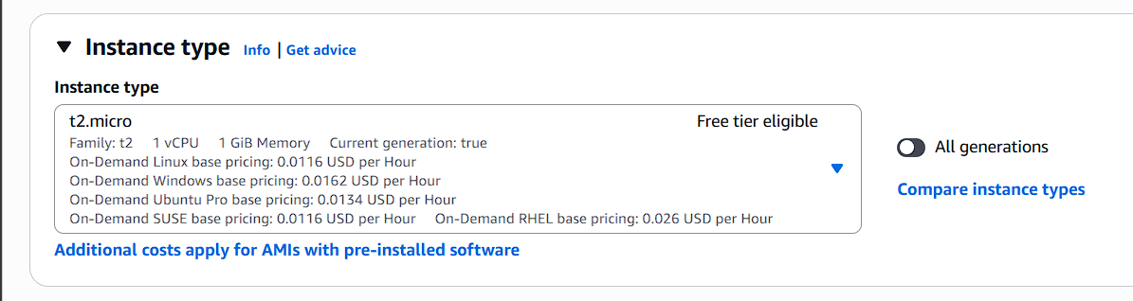

Step 5: Create Key Pair
Click Create new key pair
Name:
studentname-key
Download .pem file.
⚠️ Save safely — cannot download again.

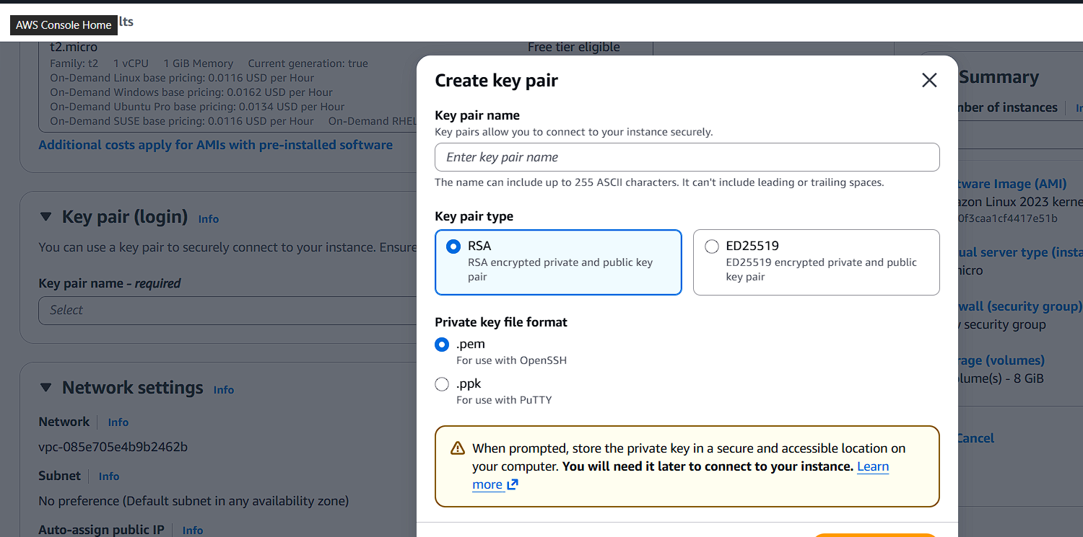
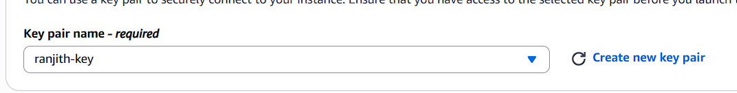

Step 6: Configure Network Settings
Click Edit:
- Auto-assign Public IP → Enable
- Create new Security Group
Add Inbound Rules:
Type | Port | Source
SSH | 22 | My IP
HTTP | 80 | Anywhere

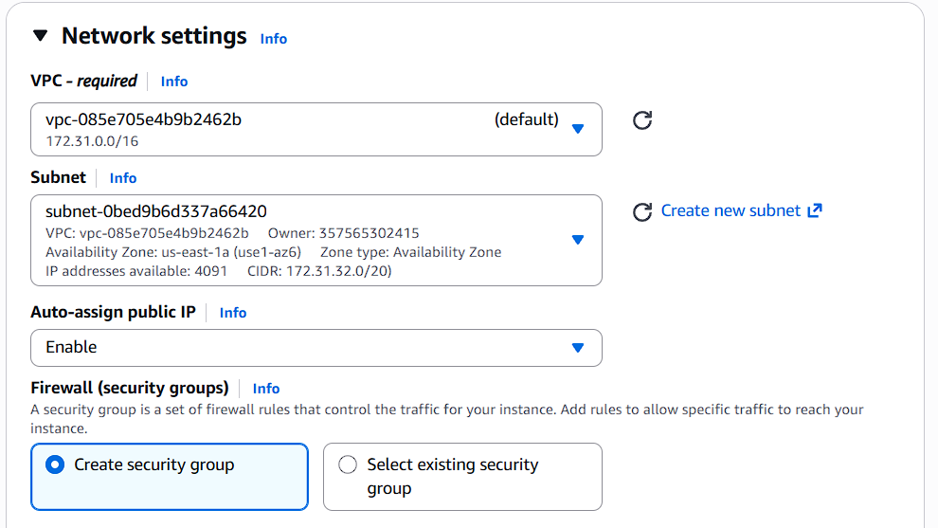

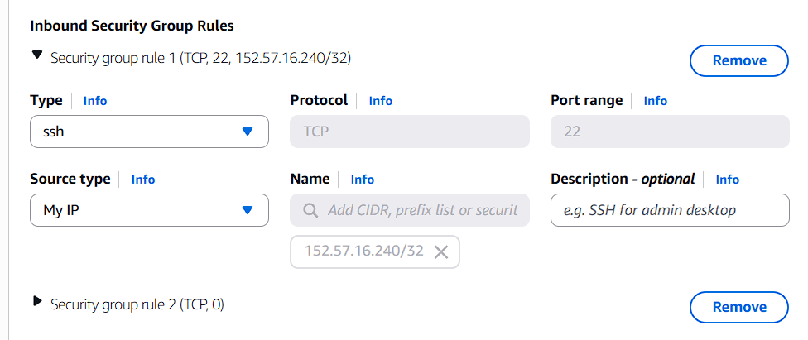

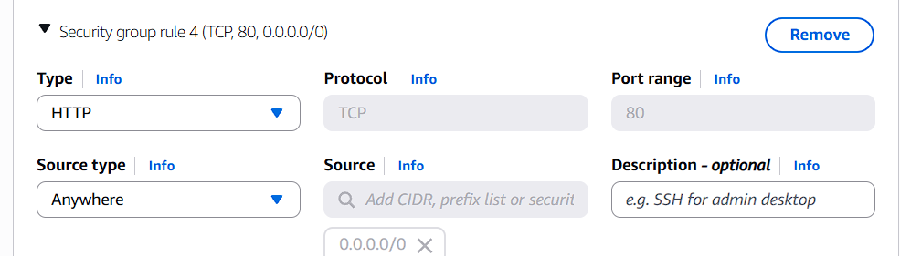

Step 7: Storage
Keep default:
8 GiB gp3

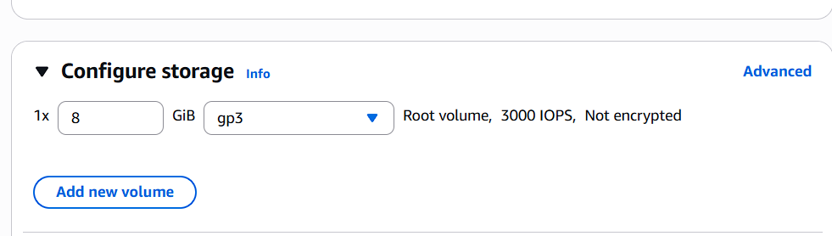

Step 8: Launch Instance
Click Launch Instance
Wait until:
Instance state → Running
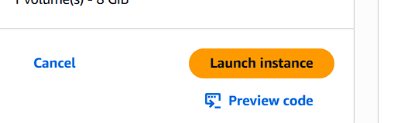

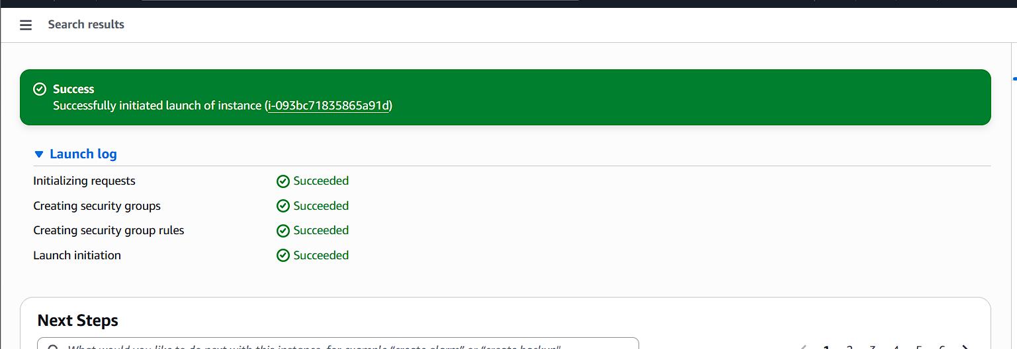

Step 9: Connect to Linux VM
Option 1: EC2 Instance Connect (Browser SSH)
OR
Option 2: From your local system:
chmod 400 studentname-key.pem

ssh -i studentname-key.pem ec2-user@<Public-IP>

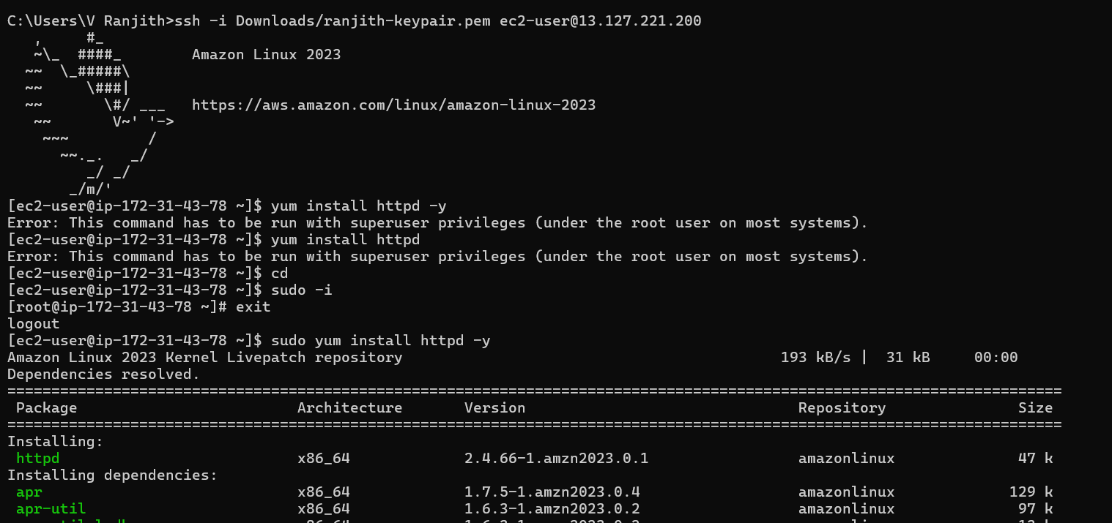

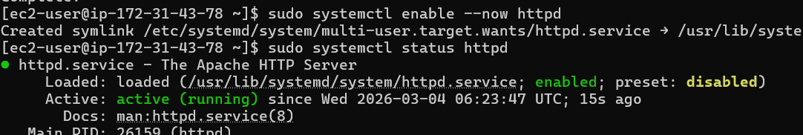

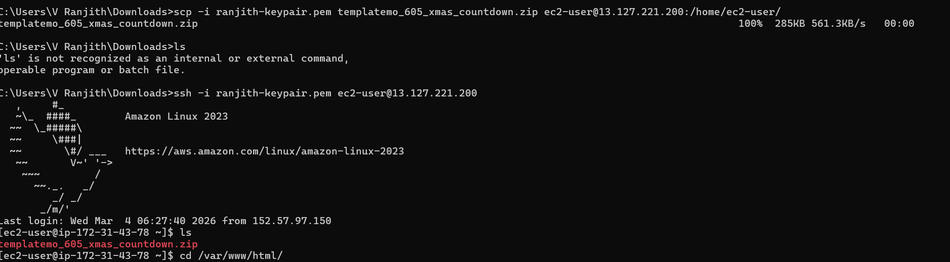

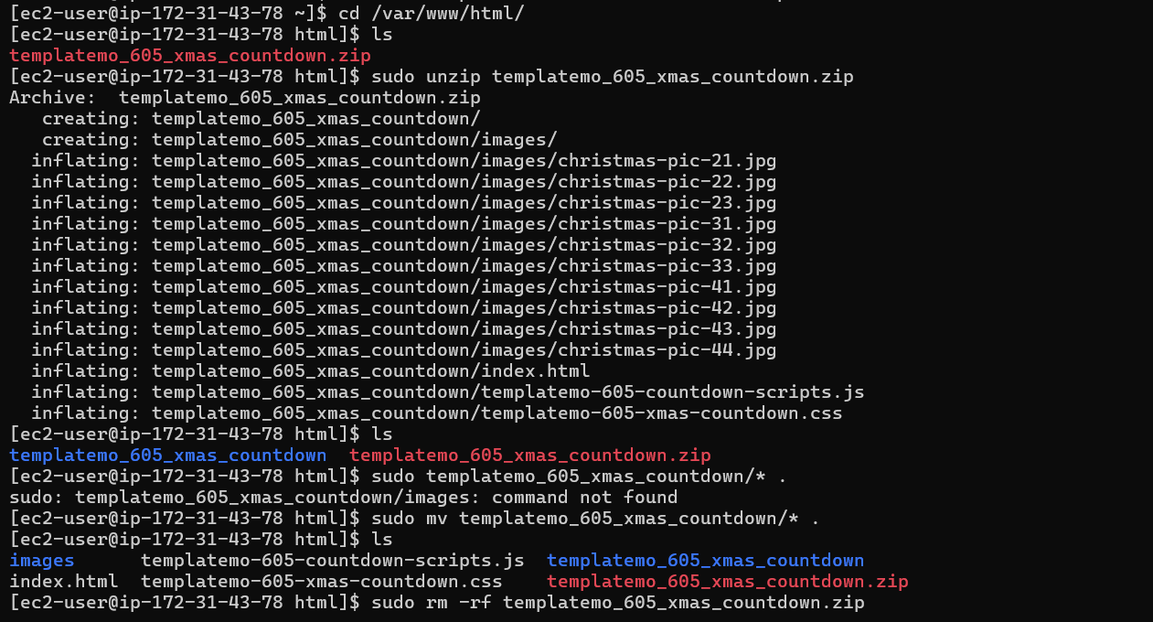

Step 10: Test Web Server (Optional)
Install Apache:
sudo yum install httpd -y
sudo systemctl start httpd
Open browser:
http://<Public-IP>
You should see Apache page.



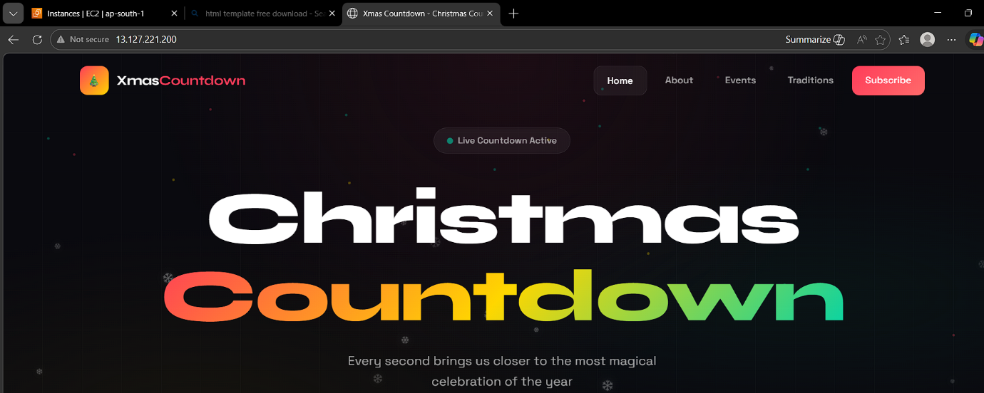

🪟 PART 2 — Create Windows EC2 Instance

Step 1: Launch New Instance
Click Launch Instance
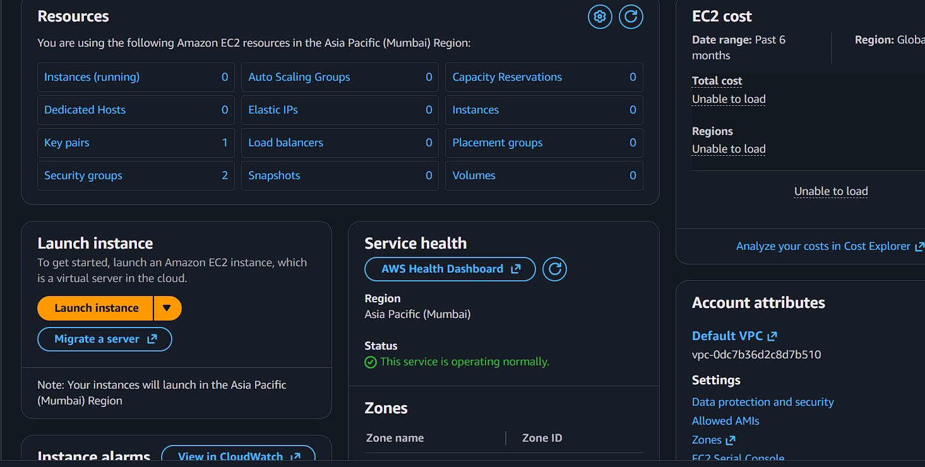

Step 2: Name It
studentname-windows-vm
Example:
saravana-windows-vm

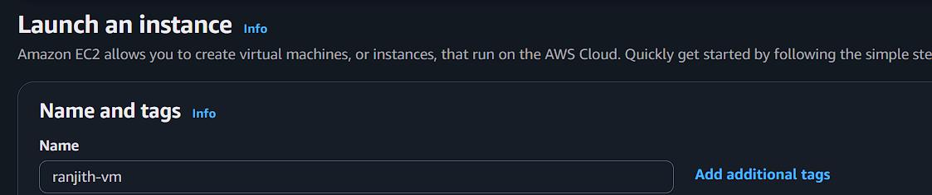

Step 3: Choose AMI
Select:
- Microsoft Windows Server 2022 Base (or) Microsoft Windows Server 2025 Base

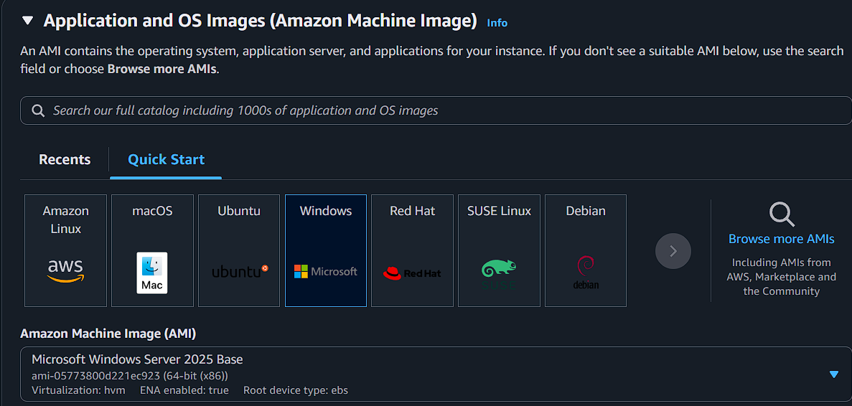

Step 4: Instance Type
Select:
t2.micro

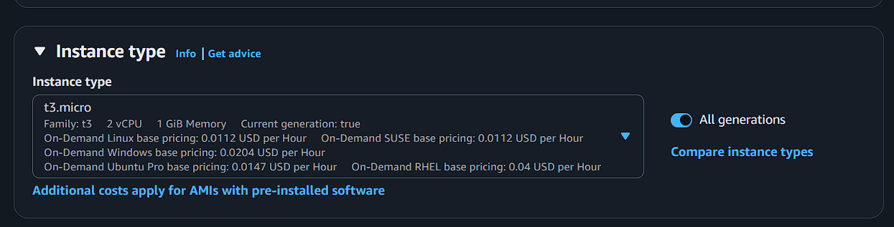

Step 5: Key Pair
Use the same:
studentname-key
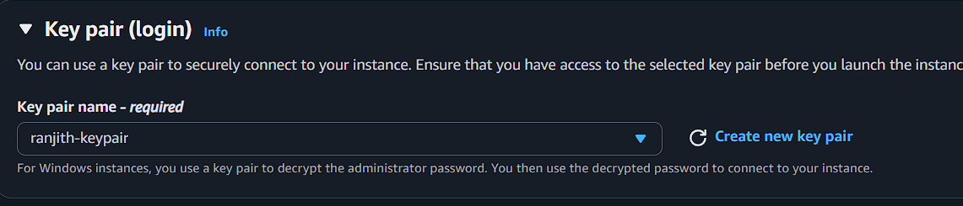

Step 6: Network Settings
Inbound Rules:
Type | Port | Source
RDP | 3389 | My IP

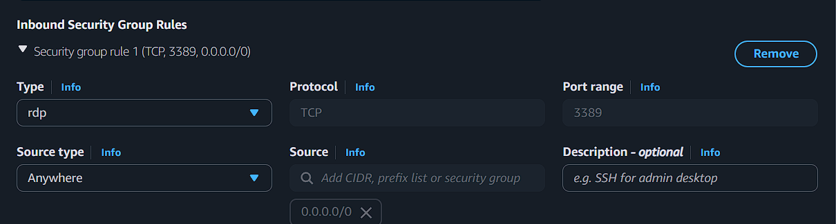

Step 7: Storage
Default:
30 GiB

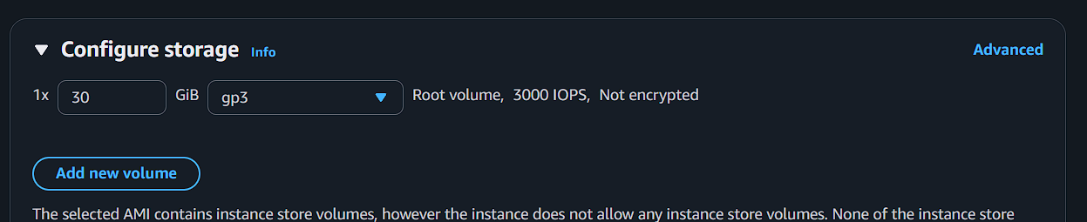

Step 8: Launch
Wait until:
Running

Step 9: Connect to Windows
- Select instance
- Click Connect
- Choose RDP client
- Click Get Password
- Upload your .pem key
- Decrypt password
- Open Remote Desktop
- Connect using:
  - Public IP
  - Username: Administrator
  - Decrypted Password

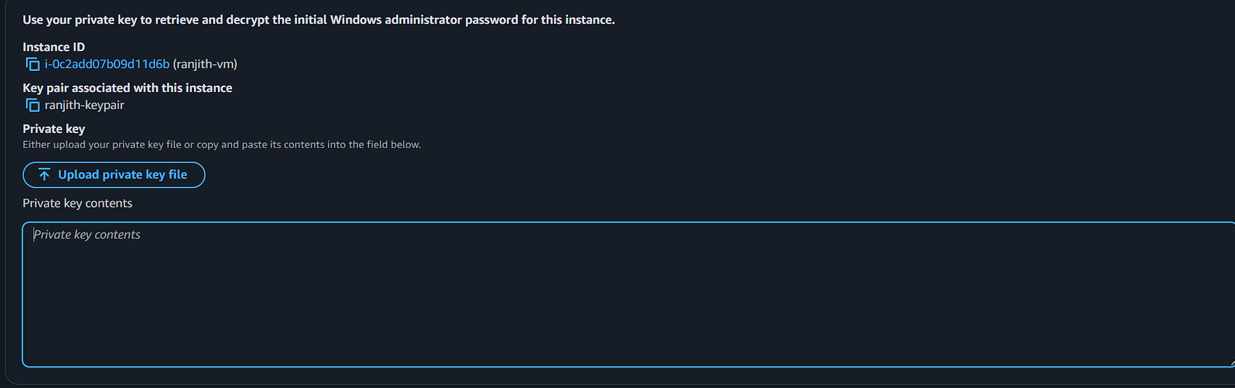

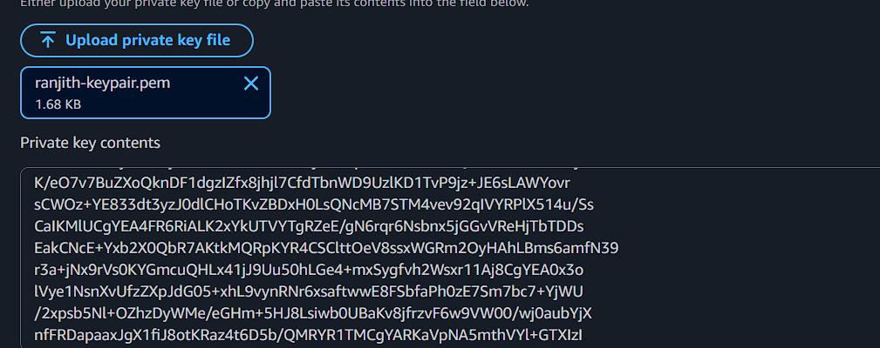

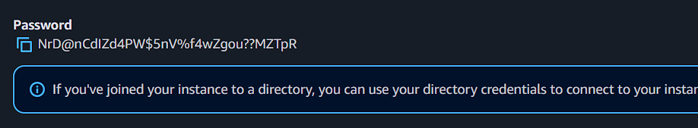

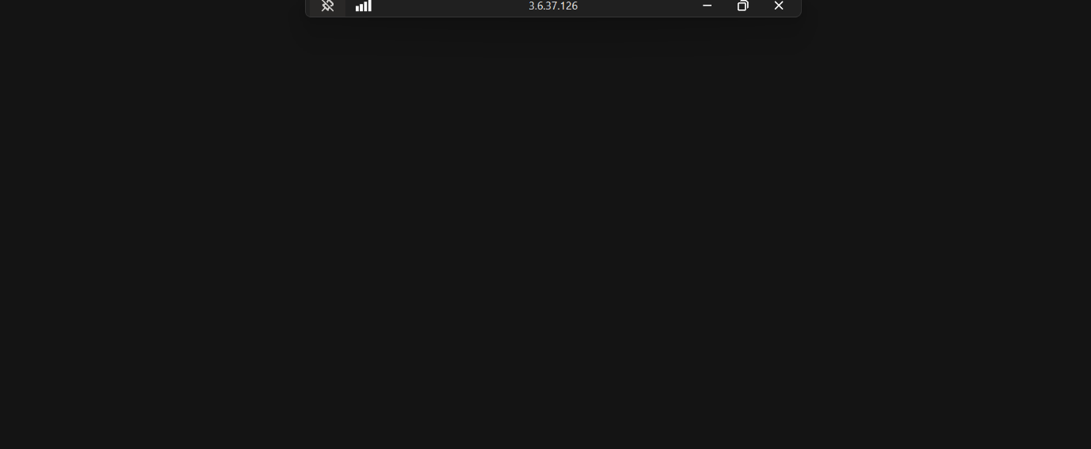

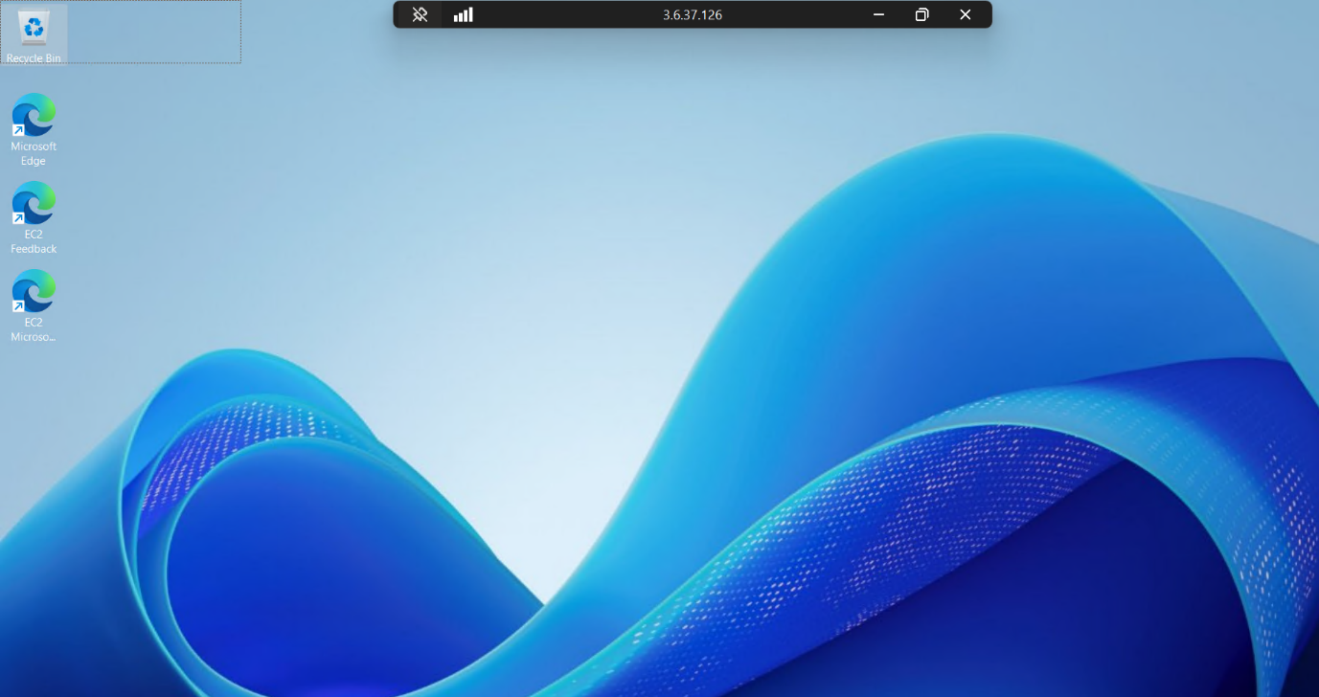

🧹 Cleanup (VERY IMPORTANT)
To avoid charges:
- Select both instances
- Click Terminate
- Delete unused Elastic IP (if created)

🎯 Expected Outcome
You should now understand:
- AMI
- Instance type
- Key pair
- Security group
- Public IP
- Storage (EBS)
- Linux vs Windows access difference

